New Physics Employee To-Do List

On your first few days at CRMC, work with coworkers to do the following. Tasks with an asterisk (\*) apply to consultants (e.g., from K&S) only: they should have already been completed for CRMC employees. Tasks with an obelisk (†) apply only to physicists.

1. †Read [Notes for New Physicists](file:///T:\Physics\New%20Hires\Notes%20for%20New%20Physicists.docx).
2. Take a tour of the department.
3. \*Get your badge from HR.

The job title for consultants is the same as we would use for a CRMC employee. E.g., a consultant physicist is a *Radiation Physicist*.

Do this ASAP as individuals without badges are technically not allowed in the building.

1. \*Set up your CRMC domain user account.
   1. Have someone put in a HelpDesk ticket.

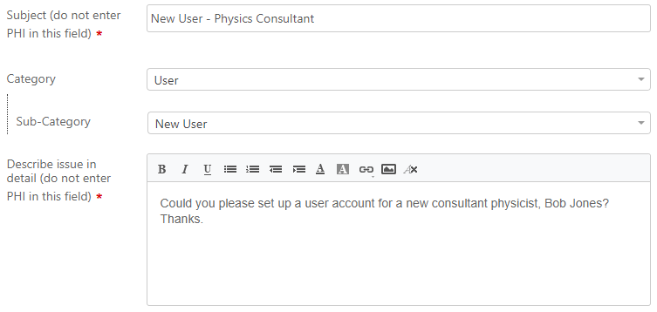

* 1. IS will send you an external user agreement form. Print it, fill it out, scan it to a file, and email it to the address listed on the form.

1. Set up MOSAIQ.
   1. Put in a HelpDesk ticket to create an account.

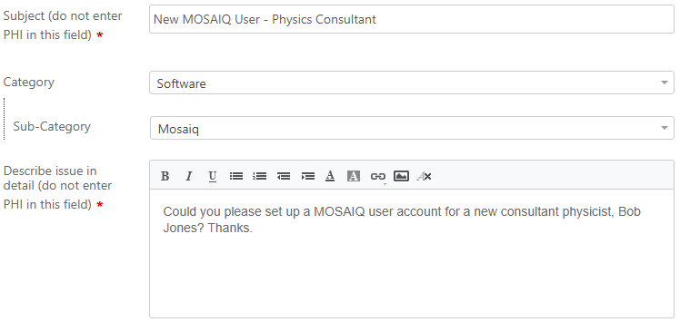

* 1. Mimic the MOSAIQ Workspace layout of someone else in your role. See the MOSAIQ user documentation for how to do this.

1. Set up RayStation.

Ensure that you can log in to Citrix. If login or autologin does not work, contact IS.

1. Set up your Tomo account.

Put in a ticket for [redacted] in IS to create a Tomo account.

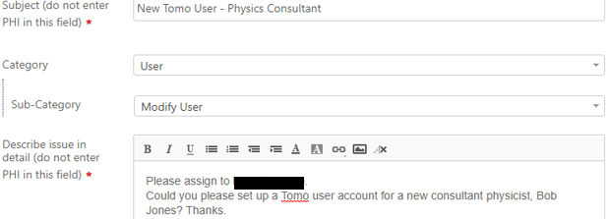

1. †Set up TQA.
   1. Put in an Accuray support ticket to whitelist your IP address for TQA. The Accuray support ticket URL is listed in the [Contacts](file:///T:\Physics\Info%20Spreadsheets) spreadsheet.
   2. The TQA URL is listed in the [Credentials & Computer Info](file:///T:\Physics\Info%20Spreadsheets) spreadsheet. Go to that URL and create an account.
   3. Add a TQA shortcut to your desktop.
2. Set up Mobius.
   1. Have anyone with Administrator role in Mobius create your account. Physicist and physics assistant users should be both Administrator and Physicist.
   2. Add a Mobius shortcut to your desktop.
3. †Set up SunCheck.
   1. Have anyone with admin rights in SunCheck create your account.
   2. Add a SunCheck shortcut to your desktop. The SunCheck URL is listed in the [Credentials & Computer Info](file:///T:\Physics\Info%20Spreadsheets) spreadsheet.
4. If any of the network drives (except Y:) listed in [Credentials & Computer Info](file:///T:\Physics\Info%20Spreadsheets) are not mapped on your PC, [map them](file:///T:\Physics\QA%20&%20Procedures\IT).
5. Add your contact info and CRMC username to the [Contacts](file:///T:\Physics\Info%20Spreadsheets) spreadsheet.
6. [Optional] Set up vendor user community accounts at the links listed in the [Useful Links](file:///T:\Physics) document. For Ray Community, you must email support to create an account. The support email is in the [Contacts](file:///T:\Physics\Info%20Spreadsheets) spreadsheet.